Actions for this week:
* Train and test DeepConvContext on the RealWorld and LARa datasets
* Design an additional new model
* Prepare the work for measuring model size, inference latency and energy consumption for all models
* Continue writing the literature review
* Write a draft of the RealWorld dataset preprocessing and send it to my supervisor
* Change the LARa experiments from single-fold mode to running all folds
* Conduct MiniRocket sensitivity and robustness experiments
* Start to organise and consolidate the project process

What did I do this week? Why did I do it?
1. Last week I found that, on the RealWorld dataset and using the same accuracy metric as in my experiments (LOSO Macro F1), DeepConvContext is one of the best-performing models and represents a current state-of-the-art backbone. It is also relatively lightweight, with a training time that is not too long, which makes it suitable for me to reproduce. Therefore, I added this model to my list of baseline models.

2. I designed a new model that combines the strengths of rTsfNet, DeepConvContext, and Transformer-based (or other) architectures.

3. For all the models I have used so far, I have measured their accuracy. On the RealWorld dataset, I have also measured the model size, inference latency and energy consumption of the first six baseline models (KNN, Random Forest, InceptionTime, TST, MiniRocket and MultiRocket). This means I have not yet completed the four-dimensional measurements (accuracy, size, inference latency and energy consumption) for all the models I currently use. Next, I need to prepare to fill this gap.

4. I continued writing the literature review, aiming to send a draft to my supervisor next week.

5. I wrote a draft of the RealWorld dataset preprocessing, sent it to my supervisor by email, and asked for his suggestions so that I can revise it later.

6. I modified the LARa dataset pipeline from a single-fold mode to a mode that automatically runs all folds in one go.

7. I added MiniRocket sensitivity and robustness experiments, specifically evaluating how different input configurations (such as window size and sensor combinations) affect model performance, in order to identify the configuration that is the most stable and performs best.

8. I started to organise the project process. The materials I need to compile include: email correspondence with my supervisor, what we discussed in meetings, the questions I asked him, the detailed progress of my project, what I did each week, how I have been driving the project forward, and how I have been thinking about and solving problems, and so on.

Why:
1. I have already completed training and testing the first six baseline models (KNN, Random Forest, InceptionTime, TST, MiniRocket and MultiRocket) on both datasets, and have obtained their four attributes: accuracy, size, inference latency and energy consumption. In addition, for the two extra models I added – the official rTsfNet and my own lightweight rTsfNet – I already have accuracy results, although I have not yet measured their size, inference latency and energy consumption. Given this, my time situation still looks manageable, so I can add reproducing DeepConvContext as a stretch goal. At the same time, this will make my experiments more convincing.

2. In the original rTsfNet paper, the authors only trained and tested on four datasets: UCI HAR, PAMAP2, Daphnet and OPPORTUNITY, and they did not use strict LOSO, which is the main data-splitting strategy in my project. Last week, I ran the official-aligned version of rTsfNet on the RealWorld dataset and reported a LOSO Macro F1 of 0.8139. Although this is a reasonably good result, 0.8139 is not among the very best LOSO Macro F1 scores achieved by the most advanced models on RealWorld. By contrast, the authors of DeepConvContext reported a LOSO Macro F1 of around 0.85 on the RealWorld dataset, which shows how strong the DeepConvContext architecture is. Therefore, if I want to design a new model, it is not enough to only adopt the advantages of rTsfNet; I also need to incorporate strengths from other models that perform very well on RealWorld, such as DeepConvContext and Transformer-based architectures.

3. Completing the four-dimensional measurements (accuracy, size, inference latency and energy consumption) for all models will greatly improve the quality of my experiments.

4. My supervisor told me last week that starting to write the dissertation early is a good idea. In the past, every time I finished an experiment, I followed his advice and wrote down the results, plus a short report and summary to show him. In the meeting on 30 October, I also mentioned that I would record what I do every day, so that it would be easier later to compile everything into the project process. My supervisor was satisfied with my format for recording the project process. This means I have already shown him the project process and some of the experimental content. In addition, this week I plan to show him a written draft of the RealWorld dataset preprocessing (the methodology part). So the only major component I have not yet shown him is a draft of the literature review.

Moreover, for the three major components of the dissertation – literature review, methodology, and project process – it is impossible to finish all of them at the end of November and only then show everything to my supervisor for feedback. The best approach is to start in early or mid-November and show him some content from each part step by step. This is more efficient and also helps to adjust or decide the writing style and direction of each section.

5. The draft of the RealWorld dataset preprocessing falls under the “Tools and Techniques and construction of chosen solutions” section of the dissertation (Weighting: 30%). If I show it to my supervisor early, it can help determine the writing style I use for this section. He has previously commented that the Primary Research Plan in my proposal was too complex and not friendly enough for non-expert readers.

6. Regarding the single-fold mode on the LARa dataset, I already mentioned this in the Reflection section of my Week 6 (20–26 October) document: “At that time, in order to test in advance whether the preprocessing code had bugs, and to check whether the later baseline model code worked correctly, I hard-coded the pipeline so that it only accepted one fold at a time. Each time, all models could only be trained on a single fold. Although the code at the final stage automatically merges and summarises the results from all the folds that have been run and gives an aggregated result, I still have to wait for each fold to finish and then manually enter the number of the next fold. This is not only tedious and disruptive to other work, but also creates the risk of typing in the wrong fold number and having to spend several more hours to re-run the entire pipeline. Finally, if I later design a new model and, for example, it takes one hour to run one fold, then if I can automatically run all eight folds in one go, I can start it before going out and have the results ready when I return to the flat. But if I have to enter each fold manually, I would need to type in eight fold numbers and stay in the flat for eight hours. So I need to find a way to adjust the code.”

If I only used simple, off-the-shelf models such as KNN or Random Forest to train all eight folds on LARa, it would be manageable: these standard models are easy to import, rarely crash or produce bugs, and train quickly. But if I plan to use my own custom models, I cannot predict how long each fold will take or whether a model might suddenly fail on the last fold after all the previous folds have completed, for example due to mismatched input sequence lengths or running out of memory after accumulating too many fold outputs. If I also open several Colab sessions in parallel to run different custom models, then in each session I would need to manually switch to the next fold after some time, which is disruptive, easy to get wrong (for example by typing the wrong fold index), and has low fault tolerance.

Switching to a mode that automatically runs all folds in one go can save a great deal of time.

7. MiniRocket is the best-performing model among my initial six baseline models (KNN, Random Forest, InceptionTime, TST, MiniRocket and MultiRocket) across the two datasets; in other words, it has the best overall trade-off between accuracy, model size, energy consumption and inference latency on both datasets. Therefore, it makes sense to conduct a dedicated set of sensitivity and robustness experiments on MiniRocket.

8. The project process accounts for 40% of the overall mark. Combined with the fact that I have run a large number of experiments and have had frequent interactions with my supervisor, this means there will be a lot of evidence to compile. Therefore, I need to plan ahead.

Outcomes and findings:
1. I successfully trained and tested the hand-written, officially aligned DeepConvContext code on the RealWorld dataset. After several runs, the LOSO Macro F1 is around 0.8, which is indeed strong, on the same level as rTsfNet and higher than MiniRocket’s 0.78.

2. By combining the strengths of rTsfNet, DeepConvContext, Transformers and some other models, I designed a new model called RCCMix, which I named “RCCMix lightweight”. On the RealWorld dataset, RCCMix lightweight achieved a LOSO Macro F1 of 0.8114, which is on the same level as DeepConvContext (0.8066) and rTsfNet (0.8139). In terms of model size, energy consumption and inference latency, my rough measurements show that RCCMix lightweight and DeepConvContext are very similar, with no obvious difference. Although the new model is technically successful, it does not deliver a large improvement over previous models in any particular dimension, so I am not fully satisfied with this result.

3. Because the newly designed model performs similarly to the earlier models in all dimensions, without a clear improvement, I plan to temporarily put aside the task of completing the full set of four attributes (accuracy, size, inference latency and energy consumption) for all models. Instead, I want to see whether I can spend some time improving the new model so that it achieves a clear advantage over the previous models in at least one aspect.

4. I have written a little more than half of the literature review. I will first see whether I can successfully improve the new model so that it clearly outperforms the earlier models in at least one respect. If that works, I will then leave some time to continue writing the literature review.

5. On Monday this week, I finished the draft of the RealWorld dataset preprocessing and sent it to my supervisor by email. However, because he is very busy, he has not yet replied. I plan to mention this to him in our Thursday meeting.

6. I successfully modified the code so that the LARa dataset can now be run in a mode that automatically processes all folds in one go, instead of the previous single-fold mode. Previously, I had already completed training and testing all baseline models using the single-fold mode. To check whether the modified code has any hidden issues, I decided to sample a few models that had already been trained under the single-fold mode and run them again in the “all folds at once” mode, then compare the results with the single-fold mode to see whether there were any differences. I finally chose the KNN, Random Forest and InceptionTime models because they train quickly. The results show that, apart from small normal fluctuations, the results of KNN, Random Forest and InceptionTime are effectively the same between the original single-fold mode and the new all-folds-at-once mode. I have also provided the full training code for both modes on GitHub.


7. I completed the MiniRocket sensitivity and robustness experiments and found that the most prominent pattern in the data is the performance difference caused by window length. Sensors are also very important, especially the gyroscope, while the overlap rate is less important. In addition, my current baseline setting (3-second windows) may not be optimal; increasing the window length to 5 seconds can improve performance. Another important finding is that I had always trained MiniRocket on a high-memory CPU (53 GB).
This week, on one particular day, I suddenly became curious about the other hardware accelerators in Colab, especially the TPU, because I had previously only used CPU and GPU. After looking into it, I found that, without changing the experimental results at all, TPU supports a “super-accelerated” version of MiniRocket training. In particular, for large-scale parallel acceleration, the high-memory CPU (53 GB) can run out of memory, whereas the 172 GB TPU does not have this issue, which can save a lot of training time. It seems that earlier I was simply too busy to spend extra time thinking about the role of TPUs. This shows that preparing and planning in advance is really important.
(The reason I do not use GPU to train MiniRocket is that the MiniRocket implementation I use is the sktime version, which only supports CPU. This also makes it easier to align my experimental results with previous papers that also trained MiniRocket on CPU.)
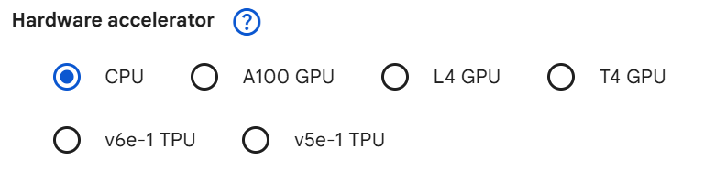

8. I organised part of the project process evidence by creating a “project_process” folder on GitHub, and inside it I created separate subfolders for each week. Since I started the project on 1 September (strictly speaking, around 28 August), I plan to record everything week by week from 1 September onwards, which also aligns with my supervisor’s suggestion that weekly records are best.

Reflection:
1. I realised that the DeepConvContext I initially reproduced was only one of its variants: the unidirectional 1-layer LSTM version. In fact, DeepConvContext has multiple variants, each with its own characteristics. From the “Architecture variants” section and the ablation studies in the paper, the main dimensions are:

Inter-window module type (three options):

* LSTM
* Multi-head self-attention
* Transformer

Direction (two options):

* Unidirectional
* Bidirectional

LSTM depth (two options):

* 1-layer LSTM
* 2-layer LSTM

On the RealWorld dataset, their LOSO Macro-F1 (single wrist location) is:

Unidirectional:

* LSTM: 86.49%
* Attention: 86.59%
* Transformer: 63.60%

Bidirectional:

* LSTM: 86.42%
* Attention: 89.71%
* Transformer: 62.14%

So I realised that I had only used one DeepConvContext variant, and not the best-performing one on RealWorld, which might make my evidence a bit weaker. Therefore I added the best-performing DeepConvContext variants on the single wrist setting and ended up using three variants in total: unidirectional LSTM, bidirectional LSTM and bidirectional attention. At the same time, because the official batch size for bidirectional LSTM is 100, which is quite time-consuming for a time-limited MSc project, I introduced some acceleration strategies and increased the batch size to speed up training. However, this accelerated version needs to be trained on a Google Colab A100 80GB GPU.

Another question I had was: in the original DeepConvContext experiments, the best variants achieved close to 0.9 LOSO Macro-F1 on RealWorld with a single wrist location, whereas in my experiments they only reach around 0.8. Why is there such a big gap? After investigation, I found that the main reasons are completely different data protocols plus implementation/training details. For example, the DeepConvContext paper uses “RWHAR · wrist · 1s/60% · 3-axis ACC · their own preprocessing and windowing protocol”, while my experiments use “RealWorld+ · waist · 3s/50% · 6-axis ACC+GYRO · my own windowing rules”. My protocol is inherently more “strict/difficult” than theirs. The 0.86–0.89 numbers in the DeepConvContext paper typically come from multiple random initialisations and multi-fold averaging, and they may also choose a particularly good run for the table. In short, we are doing two completely different experiments. DeepConvContext is the “main character” in their pipeline, and many details are tuned specifically for it (window length, sequence length, LSTM size, regularisation, etc.). In contrast, in my experiments I use a unified, model-agnostic preprocessing and hyperparameter setup to avoid overfitting tuning to a single model, which leads to more conservative performance estimates.

2. By improving RCCMix lightweight, I designed a new model. Since about 75% of the architecture is shared, I kept the name RCCMix, and the remaining 25% consists of enhanced modifications. In my experiments, RCCMix achieved a LOSO Macro-F1 of 0.853, far ahead of all other models and clearly outperforming the second-best model, rTsfNet (0.8139). In other words, the new model design is successful. However, in terms of model size, energy consumption and inference latency, RCCMix is weaker than the DeepConvContext variants but stronger than rTsfNet. This can be seen as the cost of improving accuracy; there is no model that is best in every dimension. Overall, this new model is a clear success compared with the earlier RCCMix lightweight and represents a substantial contribution. Based on my full experimental pipeline, the 0.853 result is very reliable and credible, and at the single-waist setting it effectively reaches current state-of-the-art performance, even higher than the results reported in some previous work.

From the perspective of academic originality, I have not seen exactly the same combination in the literature (SE + multi-scale depthwise convolution window encoder + geometric statistics as conditioning + FiLM-style LayerNorm on top of a Transformer + a [CLS||mean] style head), although each component individually comes from existing work. So RCCMix can be considered a self-designed model architecture.

Although RCCMix lightweight performs well on RealWorld (0.81), its accuracy on the LARa dataset is only 0.4049. Later, I optimised the RCCMix lightweight architecture based on the characteristics of the LARa dataset and developed a LARa-optimised version of RCCMix lightweight. Its accuracy improved significantly to 0.4663.

3. Most of this work will probably need to be scheduled into next week.

4. My supervisor previously told me that the literature review should be closely aligned with my own research direction and used to support my research questions, and that it is impossible to cover everything. I think my literature review probably needs to be relatively long, because my experiments cover many aspects, especially the sections that carefully sort out traditional machine learning methods, deep time-series models and state-of-the-art architectures. At the same time, it needs to be organised along “problem axes / thematic axes” rather than “chronological order / individual papers”, and it must be critical and synthetic, clearly leading to my research gap and research questions.

5. My supervisor is usually very busy and may not always have time to read emails, so the 20 minutes in the supervision meeting are “golden time”, and I should ask the most important questions first. Even so, there are times when I ask too many questions and cause him to be late for his next meeting, and when I think about it later, I feel a bit embarrassed.

6. Changing the LARa pipeline from single-fold mode to the mode that automatically runs all folds has indeed saved a lot of time for developing new models. When designing a new model, the first attempts often fail or produce errors and need repeated debugging. Providing both the single-fold mode and the all-folds-at-once mode for LARa should also count as a contribution: the former allows future researchers to test individual folds to check whether a model can run at all, while the latter allows full training on all folds and provides aggregated performance over all folds.

7. My previous choice of a 3-second window is not the best setting to fully exploit MiniRocket’s performance; 3 seconds is more of a good compromise for most models. Some models perform better on short windows (1 second), and some perform better on long windows (5 seconds). To keep the comparisons as fair as possible across all models, I chose a 3-second window as a middle ground. In an ideal scenario with more time, I should test multiple window lengths.

8. After creating all the project process folders on GitHub, I feel my thinking has become much clearer about how to organise all the project process evidence and what content I need to write. Starting from 1 September also allows me to properly show the full continuity of my project.

Have I finished this week’s actions? What percentage? If not, how to improve?
Completion rate: 75%
I have not yet finished measuring model size, inference latency and energy consumption for all models.
The first full draft of the literature review is still missing part of the content.
The project process is not fully organised yet.

Actions for next week:
* Organise the code and push it to GitHub
* Conduct an in-depth analysis of RCCMix
* Implement and refine the inference latency measurement code
* Implement and refine the model size measurement code
* Further organise and document the project process
* Complete the four-dimensional measurements (accuracy, size, inference latency and energy) for the remaining models

Email record with my supervisor Halloran:
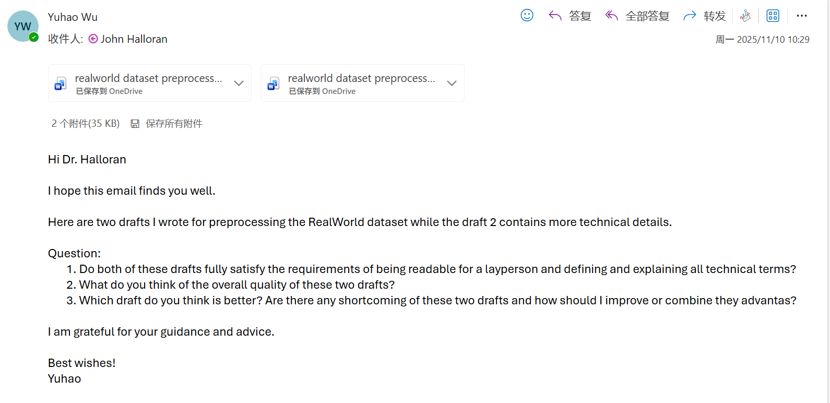
My supervisor was too busy to reply, so I asked him directly in the meeting.

Meeting part:
My supervisor gave me feedback and revision suggestions on my two drafts of the RealWorld dataset preprocessing section (I have already uploaded both drafts to GitHub).
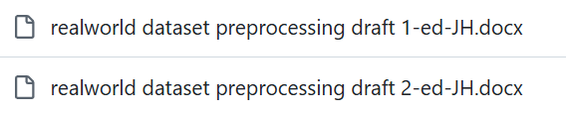
First draft:
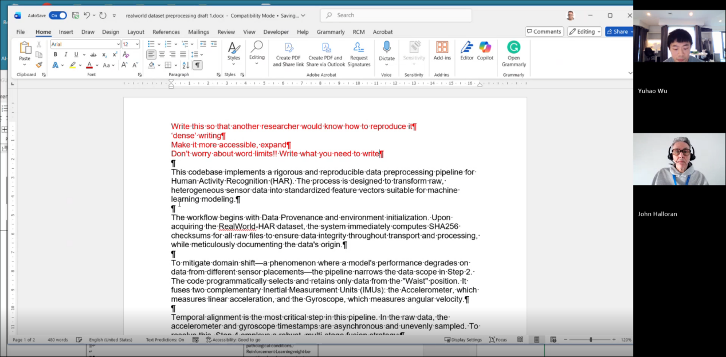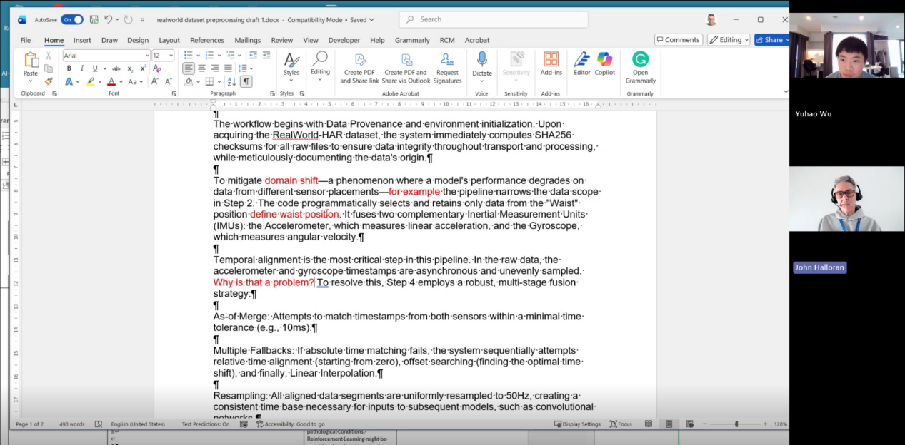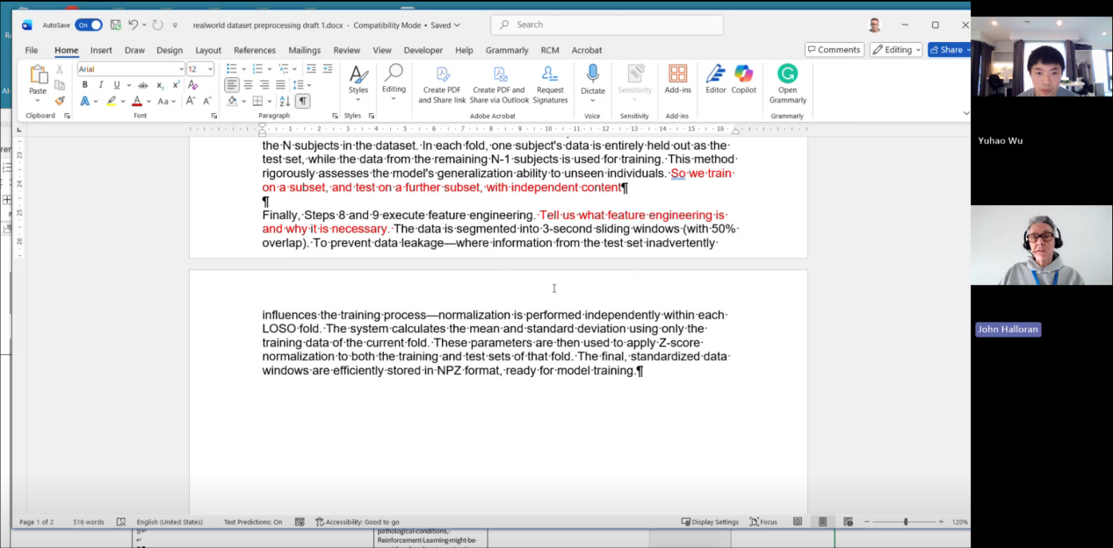
Me:
“They are two different writing styles. The second one includes more technical details.”

Supervisor Halloran’s reply:
“Okay, let me give you my feedback. I think the main issue is the main writing problem you have – which we have talked about before – your writing is too ‘dense’, too compact. This style is very ‘packed’ and hard to read. You need to spread the text out a bit more so that it is easier for the reader to understand.”

Me:
“Yes, but I have a question. Because there is a word limit, and I also have to write the literature review and I have done many experiments, there is a lot I need to write, so it ends up being dense.”

Supervisor Halloran’s reply:
“Right, well. Okay, I will write that in my comments. You don’t need to worry about the word limit. Just write what you need to write, okay? In my twenty years at Coventry University, I have never given a lower mark because a student went over the word limit. Most of my colleagues are the same. We don’t really care about the word limit. Word limits are more for other disciplines, like journalism, history, English literature. In computer science, for formal publications such as journal or conference papers, there are of course word limits. But for your dissertation, imposing a strict word limit is actually a bit ‘artificial’, because you are writing about software, development processes and analytical work. Limiting the length is not really fair. Formally, the university will specify a word limit, but in practice we do not strictly enforce it. So you really do not need to worry about the word count, okay? Just make sure you explain everything that needs to be explained clearly. I will also note this down in my comments.”

“For example, what is ‘domain shift’? You mention this concept here, right? But you need to give an example and explain it clearly. What does ‘waist location’ mean? You need to define the concept of ‘waist-worn placement’ clearly. These days, most people know what an accelerometer is and what an inertial measurement unit is, so you don’t need to worry too much about accelerometers and gyroscopes – those are relatively common concepts. But for ‘methodologically specialised concepts’, you need to define them more clearly and give examples, do you understand?”

“First, make the problem itself clear. In other words, you should ask yourself some very obvious questions, such as: Why do you need ‘temporal alignment’? What happens if you do not do temporal alignment? What you really want to say is something like: our data must be organised around ‘the human posture/position at a given point in time’. To achieve that, we have to align all the data to the same time point; otherwise, the activity data cannot be interpreted correctly, right? That is basically what you mean.”

Me:
“Yes.”

Supervisor Halloran’s reply:
“But you haven’t actually written these sentences out in the report. So again: you need to write more and turn what you have in your head into actual text, okay? In fact, you are talking about two things at the same time here. As you said, on the one hand you are describing ‘data preprocessing’, but on the other hand you are also explaining ‘what types of preprocessing you did and why you did them’. I think what is often missing at the moment is the part that explains ‘why these preprocessing steps are necessary’.”

Me:
“Yes, so I need to add more about ‘why they are necessary’ and also write them in enough detail.”

Supervisor Halloran’s reply:
“Exactly, that is it. Let me emphasise again: you can end this section with a very simple explanation, for example saying that we train on one subset of the dataset and test on another ‘content-independent subset’. In other words, we use the same dataset, but we split it into a training set and a test set – as long as you explain it clearly, that is fine. Also, you may feel that I am being a bit repetitive, but you still need to tell the reader what ‘feature engineering’ is. Likewise, explain why feature engineering is necessary. Writing it this way has two purposes: first, it shows that you really understand what you are doing; second, it makes your writing accessible to more readers, not just experts, which is what I mentioned before about making the text easier to read. But in terms of technical content, you have done very well; I don’t have any technical criticisms. The problem is only the writing style. So I’ll save this version for now.”

Second draft:
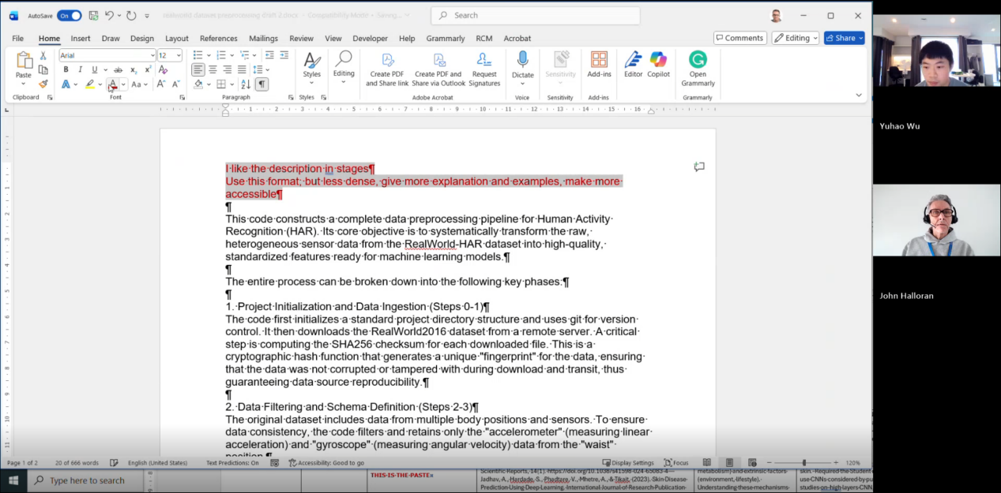
Me:
“Yes, I will add more explanations later, so that others will find it easier to understand.”

Supervisor Halloran’s reply:
“Exactly, that is completely right. Okay, I will jot down a brief note here. Mainly I just need to say that I have helped you revise this one. What time is it now? Right, we don’t have much time left. Let’s quickly look at the other one. Oh, this is the second draft. Oh, this is very good. Here you are presenting it as a sequence of stages/steps, which is excellent, because other researchers can follow this pipeline to reproduce your experiments and replicate your work. So this format is very good.”

Me:
“That is because it follows my actual experimental workflow.”

Supervisor Halloran’s reply:
“Then that is great. And in other respects, my comments are quite similar, right? You still need to write more about ‘why it is necessary’ and give more examples. That way the text will be easier to read and easier to understand. This one is good – I think this version is better, because you separate the different stages/steps. You can go with this format; it works. But, as I said earlier, try not to make it so dense. Add more explanations and examples. Make the content easier to ‘get into’ and easier to read. But overall, this is very good work. My mouse seems to have disappeared – wait a moment, I will close it and open it again. I will save this version first and then send the annotated file in the chat.”
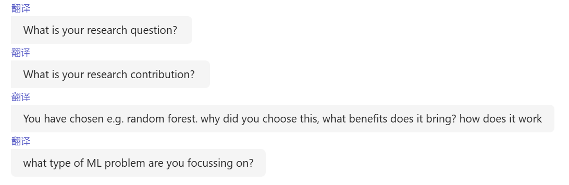

Then I showed my supervisor four sets of experimental results and my overall experimental workflow:

On the screen there were four Colab sessions, but due to time constraints, I only briefly talked my supervisor through the report; I did not present and explain each set of experimental results in detail one by one.
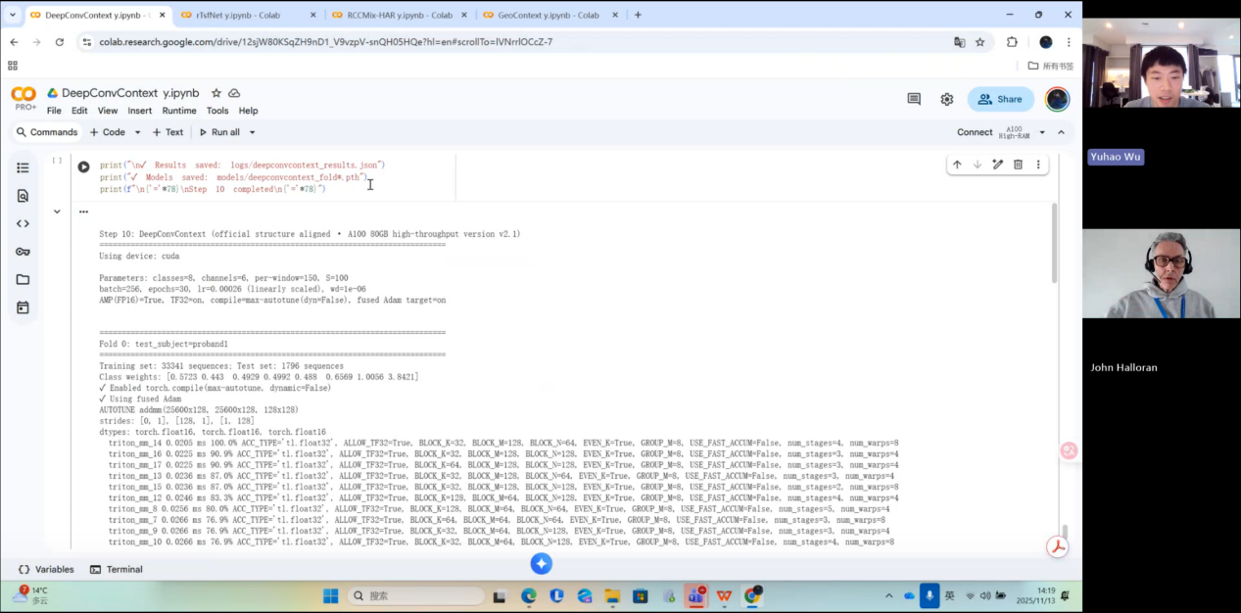
Me:
“I added two state-of-the-art models, DeepConvContext and rTsfNet, as my baseline models. Then, by combining the strengths of rTsfNet, DeepConvContext, Transformers and some other models, I designed two new models.”

Showing my supervisor the overall experimental workflow:
(Note: the “RCCMix” mentioned here is the lightweight version of RCCMix, not the RCCMix with LOSO Macro F1 = 0.85 mentioned earlier. I did originally design a model called GeoContext, but because its overall performance was worse than RCCMix lightweight, and because after the meeting with my supervisor I successfully designed the “real” RCCMix with LOSO Macro F1 = 0.85, I removed GeoContext from my list of self-developed models and kept only RCCMix and RCCMix lightweight.)
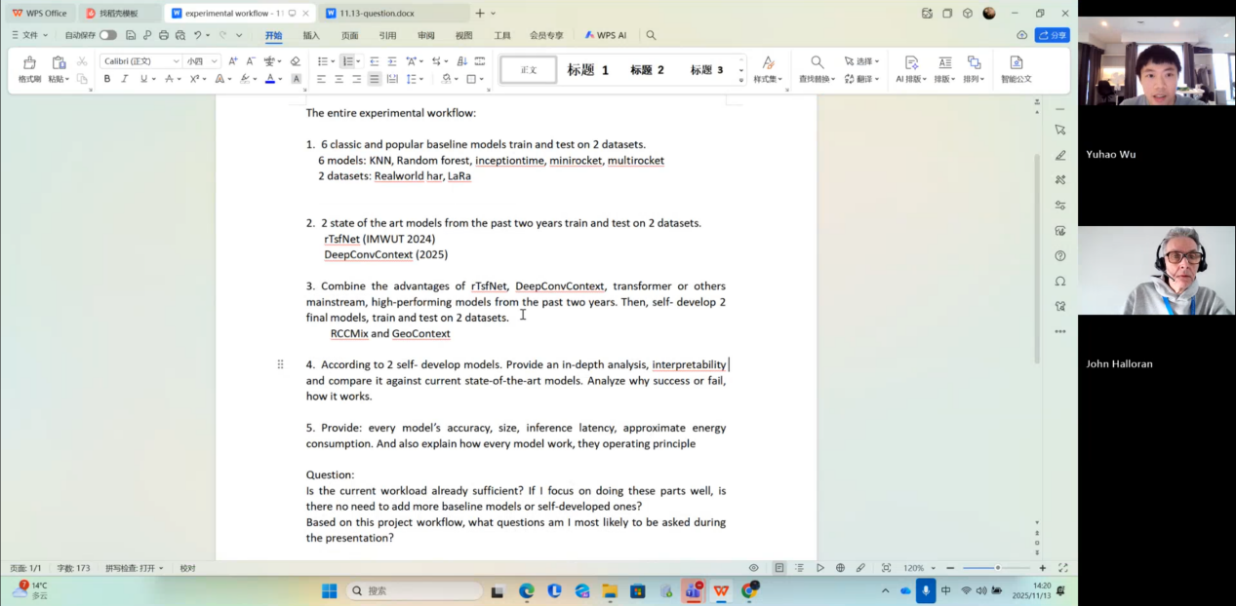
Me:
“This is the overall workflow of my experiments. The new methods I propose in the experiments are the two models that I designed myself.”

Supervisor Halloran:
“So what you are going to do next is to compare a large number of models, plus two current state-of-the-art models, and then run various combinations of experiments. Okay, that is actually a very large amount of work.”

Me:
“Yes.”

Supervisor Halloran:
“How confident are you that you can complete all this? Because it is indeed a heavy workload.”

Me:
“Because I have already completed the preprocessing for both datasets, and I started this project at the beginning of September. I also did a project in the human activity recognition area last semester.”

Supervisor Halloran:
“Good. Very good. So what you mean is that this workload is manageable for you and that it is feasible, right?”

Me:
“Yes.”

Supervisor Halloran:
“Then that’s good. Your question is: is the amount of work you have already planned enough? The answer is: yes, it’s enough – more than enough. If you focus on doing these parts well, you do not need to add anything else. There is really no need to increase the workload further.”

Me:
“Yes, I also feel that the workload is already quite large.”

Supervisor Halloran:
“You asked what questions you are most likely to get in the presentation Q&A, right? That is a very good question. You will definitely be asked some basic, general questions, for example: what is your research question? I will also type these into the chat. Questions like: what is your research question? What is your research contribution? You will also be asked some basic machine learning questions. For example, you chose a certain model, say Random Forest, and the examiner may ask: why did you choose this model? What benefits does it bring to your project? And: how does this model work? You may be asked several questions of this kind: you chose this machine learning model – how does it work?

Also, for example: what type of machine learning problem is your project focusing on? Is it regression, prediction, or classification? These should all be questions you can answer very well.

So when students do a dissertation or project in machine learning, we always ask this type of question. On the one hand, it is to check your technical knowledge and make sure you know what you are doing; on the other hand, it is to see how you understand what ‘research’ is.

Research must make a ‘contribution’ to knowledge; it must do something new. So you need to be ready to explain: why are you doing these experiments? In what sense are your experiments new? If you can explain these things clearly, you will perform very well.

You should bear in mind that you only have 10 minutes for the presentation, which is actually very short. So my suggestion is: one slide per minute, no more. That means you should prepare about 10 slides.

You should realise that this is very difficult for many students, because everyone wants to make 30 or 40 slides. But you absolutely must not do that, because the time is limited and you have to be concise.

Me:
“I think maybe 6 slides would be enough, right?”

Supervisor Halloran:
“Enough. Good, I agree with you. And not all of the content needs to be technical detail; you also need to talk about what your research question is, why the question is interesting, how your work contributes to knowledge, and what your research process was. It is now about time to start seriously thinking about the final presentation. I plan to send a template to all students to help you think about the structure of the presentation; that is very, very important.

Remember: do not try to talk about too many things. That is the most common mistake and the most common problem. Being able to compress your content into 10 minutes is a ‘skill’ that needs practice, because 10 minutes is really not long. Do you have any other questions?”

Next, I asked my supervisor six questions in total. Three of them were about the presentation’s Q&A session, and the other three were about the project process.

First were the three questions about the presentation’s Q&A session:

Supervisor Halloran:
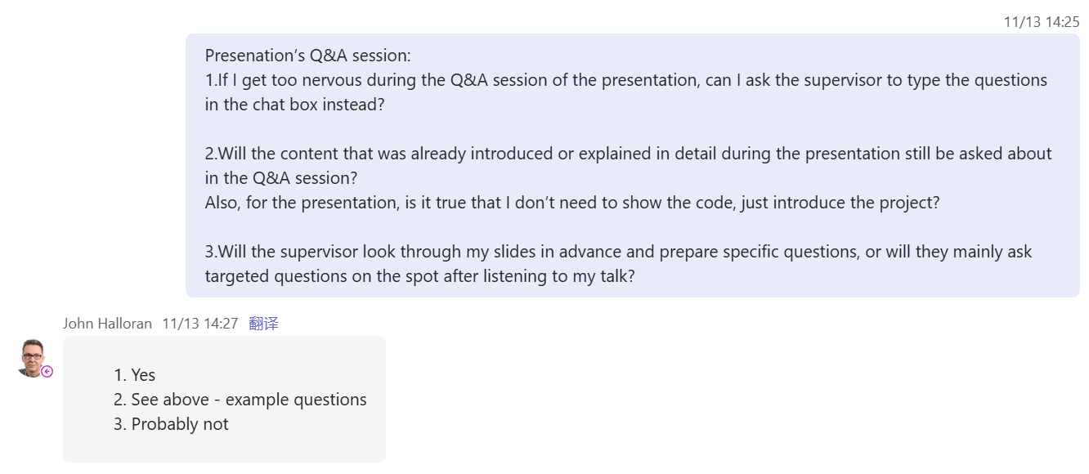
Supervisor Halloran:
Absolutely. We know the language challenges.
So of course you we will type the question as well or we will repeat it no problem.
Right. So for number 2, just see above what I've already said about example questions.
Will the supervisor look through my slides in advance for specific questions? No, probably not.
We tend to ask similar questions to all the students, right? They're going to be about.
What is the research question? Why is it important? What's your contribution and then the rest of it is technical questions, OK. And the technical questions could be quite high level as I say about how does this machine learning model model work? How does it contrast with another model?
For your project it might be OK you're combining models. Why did you do that? What did you find out? You know, it's not going to be incredible detail. This is a master's project.
The detail happens on a PhD. If you ever do a PhD which is the highest academic qualification in the in the in the UK anyway?
There's one further academic qualification in some parts of the world. But in a PhD you're writing a book, right? Like 300 pages, and you have a PhD Viva, which is at least two hours.
The PhD viva you get very detailed questions, but not in not in Masters, so don't worry too much about real small levels of detail, but it's going to tend to be quite mid or high level, right? So there are the answers to your questions.

Then came the three questions about the project process:
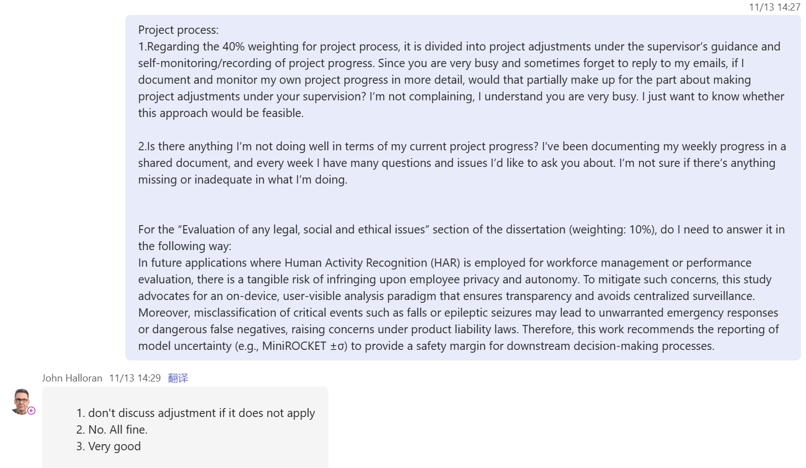
Supervisor Halloran:
“Right, if there haven’t really been any changes to your project, then there isn’t much to say about ‘project changes’, is there? If you feel that your original plan is solid and you are currently following it smoothly, then you don’t need to force yourself to write a section on ‘project adjustments’. So the essence of the first question is: if there have been no substantial changes to the project, you do not need to artificially invent ‘adjustments’ – if it does not apply, you can simply leave it out.”

“Okay, the second question is: ‘Is there anything I am doing badly in my current project progress?’ – No, everything is good.”

“As for the third question, about Evaluation (the legal, social and ethical section) – that is well written, very good, really good.”

“Coming back to the ‘project process’ part: this section is really asking you to demonstrate that you are carrying out an independent, self-driven, continuously progressing piece of work, and that it is being driven by a clear and well-defined goal. At the same time, you should not be over-reliant on your supervisor. Of course, you should keep in contact with your supervisor. But ‘dependent’ students are the ones who come to a meeting and immediately ask: ‘What should I do next? Please tell me, teacher.’ What we mean by ‘independent work’ is that you decide for yourself what you are going to do next. Then you can tell us, and explain why you are going to do it. You are able to present your own plan, you know why you are doing these things, and then you carry them out and get the work done. That is the true meaning of ‘project process’. It is not just about the meetings you have with your supervisor; more importantly, it is about the work you are doing by yourself on a day-to-day basis. Many students worry a lot about this part, which is understandable, because it counts for 40%.”

Me:
“Yes.”

Supervisor Halloran:
“So I will send everyone a ‘presentation template’. That will be one part. In addition, I will send you a document listing the main points for the ‘project process’ section. That explanation will set out the key things you should cover in the project process. I will support all students on these aspects. I will try to get the template and the key points finished and sent out before the next supervision. Okay, Yuhao, I have to go now, I’m a bit tight for the next meeting. Have a good week, and see you soon.”

Me:
“Oh, thank you, thank you very much. I wish you a good week as well.”
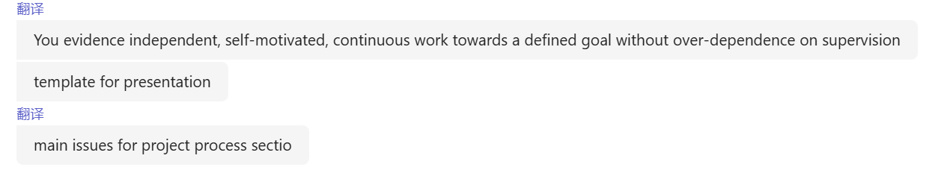

Important points from my supervisor, John Halloran (summary):

1. Overall evaluation and my current workload
From the technical perspective, my work is “very good”
My supervisor clearly stated that, from a technical point of view, my work is “really good / very good”, and he has no technical criticisms. The main issue lies in my writing style.

For the Evaluation section (legal, social, ethical issues), he said: “That’s good… That’s very good,” which shows he is satisfied with that part.

Regarding project progress:
I asked, “Is there anything I am doing badly in my current project progress?”
He replied: “No, all fine.”
In other words, he has not found anything I am doing badly so far.

My planned experimental workload is already “more than enough”
I showed him:

* Multiple baseline models
* Two state-of-the-art models
* Their various combinations, plus two new models that I designed myself

He first said this is “a lot of work”, and then asked whether I am confident I can complete it.
After I explained that I started in early September and had already done a HAR project last semester, he acknowledged:
“So you’re saying that you can do this. This is possible.”

Reading from the template, he summarised roughly:
“Is the current workload already sufficient? Yes, more than sufficient… Is there no need to add? No, there is no need for anything more.”

The meaning is:
The amount of work I have planned is already enough, even more than enough; there is absolutely no need to add further tasks.

2. Writing style: core problem and overall requirements
The main problem with my writing is that it is too dense and compact
He explicitly said:
“The main issue with your writing… is that it’s dense. This is dense writing.”

Requirements:

* Spread the text out a bit more
* Add more explanatory sentences
* Make the writing accessible to non-experts
* Do not let the “word limit” control me – I should feel free to add sufficient explanation

I was worried that: because there is a word limit + I have to write the literature review + I have done many experiments, there is a lot to cover, so I compress the writing and make it dense.

His response was very clear:

* In his 20 years at Coventry, he has never given a lower mark just because a student exceeded the word limit.
* Most of his colleagues are the same: they do not care much about the formal word limit.
* Word limits are more meaningful in subjects like journalism, history, and literature.
* In computer science, formal journal/conference papers do have word limits, but for a dissertation about software, development and analysis, enforcing a strict limit is somewhat artificial and not really fair.

Key phrases from him:
“Formally we have a word limit. Informally, we don’t.”
“Don’t worry about it. Just write what you need to write.”

He will also note in his comments that I do not need to worry too much about the word limit, in order to support me.

3. Preprocessing chapter / methodology writing: how to expand it concretely
Methodological concepts must be clearly defined and illustrated with examples
He pointed out several concepts I mentioned in the text but did not properly explain:

Domain shift
I mentioned “domain shift” but did not give a clear definition or an example.
His requirement:

* Ask myself: “What is a domain shift?”
* Then provide a clear definition plus a concrete example in the text.

Waist position
I just wrote “waist” without explaining how this location is defined.
His requirement:
“Define the waist position.”
In other words, I should clearly describe where the waist sensor is placed, how it is attached, and why this placement matters.

Temporal alignment
I mentioned temporal alignment, but did not explain “why it is needed” and “what happens if we don’t do it”.
He helped translate what I really mean into plain language:

* Our data must be organised around the human posture/position at a given point in time.
* To achieve this, we must align all data to the same time point.
* Otherwise, the activity data cannot be reasonably interpreted.

He explicitly said:
“But you haven’t said this in the report… Say more about what you’re talking about.”
So I need to write these straightforward points explicitly.

Feature engineering
He said I might be surprised, but he still wants me to:

* Explain what feature engineering is (in the context of my project)
* Explain why it is necessary

Concepts that “do not need too much explanation”
He specifically said that most people know what an accelerometer and an IMU are.
So:

* I do not need to waste much space explaining basic facts about accelerometers and gyroscopes.
* I should focus on the more specialised and distinctive aspects of my own methodology.

For each preprocessing step, I must write not only “what I did”, but also “why I did it”
He clearly pointed out that currently I am describing:

* What preprocessing I applied (what preprocessing you did)
* And to some extent, what types of preprocessing

But what is often missing is:
“Why it’s necessary.”

For each step, I should answer questions like:

* What problem does this step solve?
* What would happen if I did not do this step?
* How does it affect the downstream model or evaluation?

Closing sentences / section-level summaries: translate complex processes into simple language
He gave a very concrete “example sentence pattern”:
For example, in the data splitting part, I could simply say:

* We train on one subset of the dataset
* And test on another subset with independent content
* That is, we use the same dataset but split it into training and test sets

His suggestion:
At the end of each important subsection, use one or two simple sentences to state the core logic in plain language, instead of leaving everything at the technical-detail level.

The second preprocessing draft (the one organised by steps) is the format he prefers
His evaluation of the second draft:

* It is written as “a series of stages/steps”, which is very good.
* This structure makes it easier for other researchers to reproduce my experiments.
He said: “This is a good format.”

His recommendation:

* Use this stage/step-based format, because it follows my actual workflow and supports reproducibility.

At the same time, the general writing advice still applies:

* Make the text less dense
* Add more explanations and examples
* Improve readability and accessibility

The two ultimate purposes of my methodology writing (he explicitly summarised them)
According to him, these chapters serve two purposes:

1. Demonstrate what you know
Show that I truly understand the concepts, not just that I can write code.

2. Make the writing accessible to a wider audience
Ensure that not only experts, but also technically literate readers outside this exact subfield, can follow my explanation.

4) Presentation / oral defence: time, structure, number of slides
Presentation length = 10 minutes
He emphasised:

* 10 minutes is very short.
* Being able to present clearly within 10 minutes is a skill that needs practice.

Recommended number of slides: about 1 slide per minute
His standard advice:
“One slide for one minute, not more.”
So roughly 10 slides.

He reminded me:

* Many students make the mistake of preparing 30 or 40 slides; that is too much.
* This is a common error.

I suggested using 6 slides, and he said this is also fine:
“Enough. Good. Yeah, I agree with you.”

The presentation should not be purely technical
He explicitly listed the key points the presentation must cover:

* What is your research question?
* Why is this question interesting or important?
* What is your research contribution?
* What is your process? (how you moved from question → method → experiments → results)

He will send a presentation template to all students
He said:

* Now it is time to seriously think about the final presentation.
* He plans to send a template to help us think about the structure.
* He stressed that the structure of the presentation is very important.

Do not try to “cover too much”
He again reminded me:

* Trying to pack too much content into 10 minutes is a very common mistake.
* The real skill lies in compressing the core points into a 10-minute talk.

5. Types of questions likely to be asked in the viva (very important)
General research questions (asked in almost all ML dissertations)
He said that every student doing a machine learning dissertation will face questions such as:

* What is your research question?
* Why is it important or interesting?
* What is your contribution?

These questions check:

* Whether I understand what “research” is
* Whether my work provides a genuine “contribution to knowledge”

Basic machine learning questions
He gave typical examples:
If I choose a model like Random Forest, I may be asked:

* Why did you choose this model?
* What benefits does it bring to your project?
* How does it work (at a high level)?

I will also be asked what type of machine learning problem my project focuses on:

* Is it regression?
* Is it prediction?
* Is it classification?

He said these should all be easy for me to answer.

For my particular project (with many models and combinations), I may also be asked:

* Why are you combining models in this way?
* Why did you choose those specific combinations?
* What did you find out through these experiments?

Depth of questions: Master’s vs PhD
He used the PhD viva to help reduce my anxiety:

* Master’s viva questions are usually at a medium or slightly high level; they do not dig into extreme detail.
* Very detailed, highly technical questioning is more typical of a PhD viva:

* A PhD thesis is like a 300-page book
* The viva lasts at least 2 hours
* There is time for intense, detailed interrogation

Conclusion:
I do not need to worry too much about ultra-fine-grained questions.

Question style and language support
He explicitly acknowledged that language can be a challenge.
He promised that:

* They can type the question for me to read
* Or repeat the question
So that I have time to understand and react; “no problem.”

Whether the supervisor will pre-read the slides to tailor questions
I asked: will the supervisor look at my slides before the viva and prepare custom questions based on them?
His answer:
“No, probably not.”
Usually, they ask similar types of questions to all students (like the categories listed above).

6. Project adjustments / project process / independence
Project adjustments can be omitted if there are none
I asked whether I need to write about project adjustments.
His position is very straightforward:

* If I have not made substantial changes to the project
* And the original plan is strong and is being followed smoothly
Then there is “nothing to talk about”.

His original phrase was similar to:
“You don’t need to discuss an adjustment if it doesn’t apply.”

The essence of project process: independent, self-driven, continuous work
He gave a very clear definition of what “project process” is evaluating (crucial for the 40%):
It looks at whether I am carrying out:
“Independent, self-motivated, continuous work towards a defined goal.”

In simple terms:
It checks whether I am consistently and proactively moving towards a clear goal.

What “not overdependent on supervision” means
The university expects me to engage with supervision; that is normal.
But “overdependence on supervision” looks like this:
Every time a student comes to a meeting, the first questions are:
“What should I do next?”
“Tell me what to do.”

What they want to see as “independent work” is:

* I decide for myself what to do next
* I can explain to my supervisor:

* Why I am doing it
* What my plan is
* Why these steps are necessary
* Then I actually carry out the plan and complete the work

Project process is not just about meetings; it is mainly about what I do by myself
He emphasised:

* Project process is not simply “how many supervisions I attended”.
* More importantly, it is about all the concrete work I am doing on my own between meetings.

He also said:

* Many students are anxious about this part, which is understandable, because it counts for 40%.

He will send a guidance document on the project process
Just like the PPT template, he will also:

* Send out a “Main issues for Project process section” document
* This will list the key points we should cover in the project process part

He promised:

* He will try to prepare and send both the presentation template and the project process key points before the next supervision.
* “I will support all the students with those things.”

